# **GST Payments and Refunds**

Current GST return filing requires that every month, once GSTR-1 is filed to report Sales, one must file GSTR-3B to report the ITC and make necessary GST Payment. Also if a refund is required to be claimed the same can be done by filing relevant refund related forms.

# **A. Payments –**

## ****1. What are payments to be made under GST?****

Under GST the [tax to be paid](https://cleartax.in/s/what-is-sgst-cgst-igst) is mainly divided into 3 –

* IGST – To be paid when interstate supply is made (paid to center)
* CGST – To be paid when making supply within the state (paid to center)
* SGST – To be paid when making supply within the state (paid to state)

|  |  |  |  |
| --- | --- | --- | --- |
| **CIRCUMSTANCES** | **CGST** | **SGST** | **IGST** |
| Goods sold from Delhi to Bombay | NO | NO | YES |
| Goods sold within Bombay | YES | YES | NO |
| Goods sold from Bombay to Pune | YES | YES | NO |

Apart from the above payments a dealer is required to make these payments –

* Tax Deducted at Source (TDS) – [TDS](https://cleartax.in/s/tds-under-goods-and-service-tax)is a mechanism by which tax is deducted by the dealer before making the payment to the supplier

****For example –****

A government agency gives a road laying contract to a builder. The contract value is Rs 10 lakh.

When the government agency makes payment to the builder TDS @ 1% (which amounts to Rs 10,000) will be deducted and balance amount will be paid.

* Tax Collected at Source (TCS) – [TCS](https://cleartax.in/s/tds-and-tcs-under-gst)is mainly for e-commerce aggregators. It means that any dealer selling through e-commerce will receive payment after deduction of TCS @ 2%.

This provision is currently relaxed and will not be applicable to notified by the government.

* Reverse Charge – The liability of payment of tax shifts from the supplier of goods and services to the receiver. To know more about reverse charge check out our article [‘Know all about Reverse Charge under GST](https://cleartax.in/s/reverse-charge-gst)‘

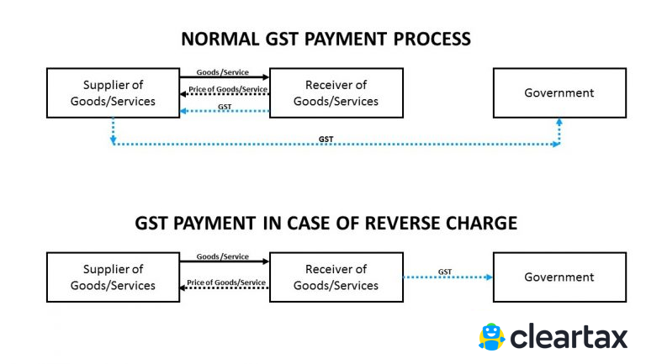

* Interest, Penalty, Fees and other payments

## ****2. How to calculate the GST payment to be made?****

Usually, the[Input Tax Credit](https://cleartax.in/s/gst-input-tax-credit/)should be reduced from Outward Tax Liability to calculate the total GST payment to be made.

TDS/TCS will be reduced from the total GST to arrive at the net payable figure. Interest & late fees (if any) will be added to arrive at the final amount.

Also, ITC cannot be claimed on interest and late fees. Both Interest and late fees are required to be paid in cash.

The way the calculation is to be done is different for different types of dealers –

**Regular Dealer**

A regular dealer is liable to pay GST on the outward supplies made and can also claim Input Tax Credit (ITC) on the purchases made by him.

The GST payable by a regular dealer is the difference between the outward tax liability and the ITC.

**Composition Dealer**

The GST payment for a composition dealer is comparatively simpler. A dealer who has opted for [composition scheme](https://cleartax.in/s/gst-composition-scheme/) has to pay a fixed percentage of GST on the total outward supplies made.

GST is to be paid based on the type of business of a composition dealer.

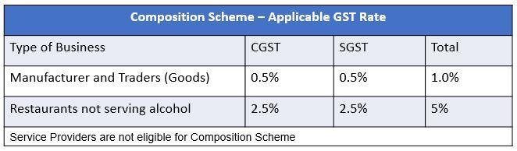

## ****3. Who should make the payment?****

These dealers are required to make GST payment –

1. A Registered dealer is required to make GST payment if GST liability exists.
2. Registered dealer required to pay tax under [Reverse Charge Mechanism(RCM).](https://cleartax.in/s/reverse-charge-gst)
3. E-commerce operator is required to collect and pay TCS
4. Dealers required deducting TDS

## ****4. When should GST payment be made?****

GST payment is to be made when the GSTR 3 is filed i.e by 20th of the next month.

## ****5. What are the electronic ledgers?****

These [ledgers](https://cleartax.in/s/e-ledgers-under-gst)are maintained on the electronically on GST Portal.

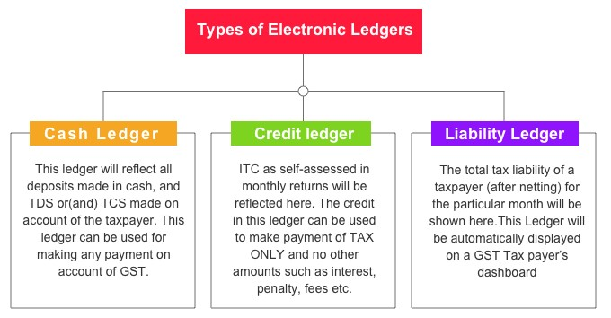

## ****6. How to make GST payment?****

**GST payment can be made in 2 ways –**

* **Payment through Credit  Ledger –**

The credit of ITC can be taken by dealers for GST payment. The credit can be taken only for payment of Tax. Interest, penalty and late fees cannot be paid by utilizing ITC.

* **Payment through Cash Ledger –**

GST payment can be made [online](https://cleartax.in/s/gst-payment)or offline. The challan has to be generated on GST Portal for both online and offline GST payment.

Where tax liability is more than Rs 10,000, it is mandatory to pay taxes Online.

## ****7. What is the penalty for non-payment or delayed payment?****

If GST is short paid, unpaid or paid late interest at a rate of 18% is required to be paid by the dealer.

Also, a penalty to be paid. The penalty is higher of Rs. 10,000 or 10% of the tax short paid or unpaid.

# ****B.**** **Refunds –**

## ****1. What is GST refund?****

Usually when the GST paid is more than the GST liability a situation of claiming GST refund arises. Under GST the process of claiming a refund is standardized to avoid confusion. The process is online and time limits have also been set for the same.

## ****2. When can the refund be claimed?****

There are many cases where [refund](https://cleartax.in/s/refund-process-under-gst)can be claimed. Here are some of them –

Excess payment of tax is made due to mistake or omission.

* Dealer Exports (including deemed export) goods/services under claim of rebate or Refund
* ITC accumulation due to output being tax exempt or nil-rated
* Refund of tax paid on purchases made by Embassies or UN bodies
* Tax Refund for International Tourists
* Finalization of provisional assessment

## ****3. How to calculate GST refund?****

Let’s take a simple case of excess tax payment made.

Mr. B’s GST liability for the month of September is Rs 50000. But due to mistake, Mr. B made a GST payment of Rs 5 lakh.

Now Mr. B has made an excess GST payment of Rs 4.5 lakh which can be claimed as a refund by him. The time limit for claiming the refund is 2 years from the date of payment.

## ****4. What is the time limit for claiming the refund?****

The time limit for claiming a refund is 2 years from relevant date.

The relevant date is different in every case.

Here are the relevant dates for some cases –

|  |  |
| --- | --- |
| **Reason for claiming GST Refund** | **Relevant Date** |
| Excess payment of GST | Date of payment |
| Export or deemed export of goods or services | Date of despatch/loading/passing the frontier |
| ITC accumulates as output is tax exempt or nil-rated | Last date of financial year to which the credit belongs |
| Finalisation of provisional assessment | Date on which tax is adjusted |

Also if refund is paid with delay an interest of 24% p.a. is payable by the government.

## ****5. How to claim GST refund?****

The [refund application](https://cleartax.in/s/refund-claims-under-gst-for-tax-and-itc) has to be made in Form RFD 01 within 2 years from relevant date.

## The form sho****Types of GST Returns****

##### ****1. GSTR-1****

[GSTR-1](https://cleartax.in/s/gstr-1) is the return to be furnished for reporting details of all outward supplies of goods and services made, or in other words, sales transactions made during a tax period, and also for reporting debit and credit notes issued. Any amendments to sales invoices made, even pertaining to previous tax periods, should be reported in the GSTR-1 return.

GSTR-1 is to be filed by all normal taxpayers who are registered under GST. It is to be filed monthly, except in the case of small taxpayers with turnover up to Rs.1.5 crore in the previous financial year, who can file the same on a quarterly basis.

##### ****2. GSTR-2A****

[GSTR-2A](https://cleartax.in/s/gstr-2a) is the return containing details of all inward supplies of goods and services i.e. purchases made from registered suppliers during a tax period. The data is auto-populated based on data filed by the suppliers in their GSTR-1 return. GSTR-2A is a read-only return and no action can be taken.

##### ****3. GSTR-2****

[GSTR-2](https://cleartax.in/s/gstr2) is the return for reporting the inward supplies of goods and services i.e. the purchases made during a tax period. The details in the GSTR-2 return are auto-populated from the GSTR-2A. Unlike GSTR-2A, the GSTR-2 return can be edited.

GSTR-2 is to be filed by all normal taxpayers registered under GST, however, the filing of the same has been suspended ever since the inception of GST.

##### ****4. GSTR-3****

[GSTR-3](https://cleartax.in/s/gst-return-gstr3) is a monthly summary return for furnishing summarized details of all outward supplies made, inward supplies received and input tax credit claimed, along with details of the tax liability and taxes paid. This return is auto-generated on the basis of the GSTR-1 and GSTR-2 returns filed.

GSTR-3 is to be filed by all normal taxpayers registered under GST, however, the filing of the same has been suspended ever since the inception of GST.

##### ****5. GSTR-3B****

[GSTR-3B](https://cleartax.in/s/gstr-3b) is a monthly self-declaration to be filed, for furnishing summarized details of all outward supplies made, input tax credit claimed, tax liability ascertained and taxes paid.

GSTR-3B is to be filed by all normal taxpayers registered under GST.

##### ****6. GSTR-4 / CMP-08****

[GSTR-4](https://cleartax.in/s/gstr4-composition-dealer-gst-return) is the return that was to be filed by taxpayers who have opted for the Composition Scheme under GST. [CMP-08](https://cleartax.in/s/form-cmp-08) is the return which has replaced the now erstwhile GSTR-4. The Composition Scheme is a scheme in which taxpayers with turnover up to Rs.1.5 crores can opt into and pay taxes at a fixed rate on the turnover declared.

The CMP-08 return is to be filed on a quarterly basis.

##### **7. GSTR-5**

[GSTR-5](https://cleartax.in/s/gst-return-gstr5) is the return to be filed by non-resident foreign taxpayers, who are registered under GST and carry out business transactions in India. The return contains details of all outward supplies made, inward supplies received, credit/debit notes, tax liability and taxes paid.

The GSTR-5 return is to be filed monthly for each month that the taxpayer is registered under GST in India.

##### **8. GSTR-6**

[GSTR-6](https://cleartax.in/s/gstr-6-gst-return) is a monthly return to be filed by an Input Service Distributor (ISD). It will contain details of input tax credit received and distributed by the ISD. It will further contain details of all documents issued for the distribution of input credit and the manner of distribution.

##### **9. GSTR-7**

[GSTR-7](https://cleartax.in/s/gstr-7-gst-return) is a monthly return to be filed by persons required to deduct TDS (Tax deducted at source) under GST. GSTR 7 will contain details of TDS deducted, the TDS liability payable and paid and TDS refund claimed, if any.

##### **10. GSTR-8**

[GSTR-8](https://cleartax.in/s/gstr-8-gst-return) is a monthly return to be filed by e-commerce operators registered under the GST who are required to collect tax at source (TCS). GSTR-8 will contain details of all supplies made through the E-commerce platform, and the TCS collected on the same.

The GSTR-8 return is to be filed on a monthly basis.

##### **11. GSTR-9**

[GSTR-9](https://cleartax.in/s/gstr-9-annual-return) is the annual return to be filed by taxpayers registered under GST. It will contain details of all outward supplies made, inward supplies received during the relevant previous year under different tax heads i.e. CGST, SGST & IGST and HSN codes, along with details of taxes payable and paid. It is a consolidation of all the monthly or quarterly returns (GSTR-1, GSTR-2A, GSTR-3B) filed during that year.

GSTR-9 is required to be filed by all taxpayers registered under GST*, except taxpayers who have opted for the Composition Scheme, Casual Taxable Persons, Input Service Distributors, Non-resident Taxable Persons and persons paying [TDS](https://cleartax.in/s/tds-under-goods-and-service-tax) under section 51 of CGST Act.

*The 37th GST Council meeting took the decision to make GSTR-9 filing optional for businesses with turnover up to Rs.2 crore in FY 17-18 and FY 18-19.

##### **12. GSTR-9A**

[GSTR-9A](https://cleartax.in/s/gstr-9a) is the annual return to be filed by taxpayers who have registered under the Composition Scheme in a financial year*. It is a consolidation of all the quarterly returns filed during that financial year.

*GSTR-9A filing for Composition taxpayers has been waived off for FY 2017-18 and FY 2018-19 as per the decision taken in the 27th GST Council meeting.

##### **13. GSTR-9C**

[GSTR-9C](https://cleartax.in/s/gst-reconciliation-statement-gstr-9c) is the reconciliation statement to be filed by all taxpayers registered under GST whose turnover exceeds Rs.2 crore in a financial year. The registered person has to get their books of accounts audited by a Chartered/Cost Accountant. The statement of reconciliation is between these audited financial statements of the taxpayer and the annual return GSTR-9 that has been filed.

GSTR-9C is to be filed for every [GSTIN](https://cleartax.in/s/gst-number-search), hence, one [PAN](https://cleartax.in/s/pan-card) can have multiple GSTR-9C forms being filed.

##### **14. GSTR-10**

[GSTR-10](https://cleartax.in/s/gstr-10-gst-final-return) is to be filed by a taxable person whose registered has been cancelled or surrendered. This return is also called a final return and has to be filed within 3 months from the date of cancellation or cancellation order, whichever is earlier.

##### **15. GSTR-11**

[GSTR-11](https://cleartax.in/s/gstr-11-uin-gst-return) is the return to be filed by persons who have been issued a Unique Identity Number(UIN) in order to get a refund under GST for the goods and services purchased by them in India. UIN is a classification made for foreign diplomatic missions and embassies not liable to tax in India, for the purpose of getting a refund of taxes. GSTR-11 will contain details of inward supplies received and refund claimed.

## ****Due Dates of Filing GST Returns****

These returns are as per the CGST Act*

|  |  |  |  |
| --- | --- | --- | --- |
| ****Return Form**** | ****Particulars**** | ****Frequency**** | ****Due Date**** |
| [GSTR-1](https://cleartax.in/s/gstr-1/" \t "https://cleartax.in/s/_blank) | Details of outward supplies of taxable goods and/or services affected | Monthly | 11th* of the next month with effect from October 2018  *Previously, the due date was 10th |
| [GSTR-2](https://cleartax.in/s/gstr2/" \t "https://cleartax.in/s/_blank)  ****Suspended**** | Details of inward supplies of taxable goods and/or services affected claiming the input tax credit. | Monthly | 15th of the next month |
| [GSTR-3](https://cleartax.in/s/gst-return-gstr3/" \t "https://cleartax.in/s/_blank)  ****Suspended**** | Monthly return on the basis of finalization of details of outward supplies and inward supplies along with the payment of tax. | Monthly | 20th of the next month |
| [GSTR-3B](https://cleartax.in/s/gstr-3b" \t "https://cleartax.in/s/_blank) | Simple Return in which summary of outward supplies along with Input Tax Credit is declared  and payment of tax is affected by taxpayer | Monthly | 20th of the next month |
| [CMP-08**](https://cleartax.in/s/form-cmp-08/" \t "https://cleartax.in/s/_blank) | Return for a taxpayer registered under the composition levy | Quarterly | 18th of the month succeeding quarter |
| [GSTR-5](https://cleartax.in/s/gst-return-gstr5/) | Return for a Non-Resident foreign taxable person | Monthly | 20th of the next month |
| [GSTR-6](https://cleartax.in/s/gstr-6-gst-return/" \t "https://cleartax.in/s/_blank) | Return for an Input Service Distributor | Monthly | 13th of the next month |
| [GSTR-7](https://cleartax.in/s/gstr-7-gst-return/) | Return for authorities deducting tax at source. | Monthly | 10th of the next month |
| [GSTR-8](https://cleartax.in/s/gstr-8-gst-return/) | Details of supplies effected through e-commerce operator and the amount of tax collected | Monthly | 10th of the next month |
| [GSTR-9](https://cleartax.in/s/gstr-9-annual-return/) | Annual Return for a Normal Taxpayer | Annually | 31st December of next financial year* |
| [GSTR-9A](https://cleartax.in/s/gstr-9a" \t "https://cleartax.in/s/_blank) | Annual Return a taxpayer registered under the composition levy anytime during the year | Annually | 31st December of next financial year* |
| [GSTR-10](https://cleartax.in/s/gstr-10-gst-final-return/) | Final Return | Once, when GST Registration is cancelled or surrendered | Within three months of the date of cancellation or date of cancellation order, whichever is later. |
| [GSTR-11](https://cleartax.in/s/gstr-11-uin-gst-return) | Details of inward supplies to be furnished by a person having UIN and claiming a refund | Monthly | 28th of the month following the month for which statement is filed |

* Subject to changes by Notifications/ Orders  
**Statement of self-assessed tax by composition dealers – same as the erstwhile form GSTR-4, which is now made an annual return with effect from FY 2019-2020 onwards.

## ****Late filing of GST Returns****

Return filing is mandatory under GST. Even if there is no transaction, you must file a Nil return.

You cannot file a return if you do not file previous month/quarter’s return.

Hence, late filing of GST return will have a cascading effect leading to heavy fines and penalty.

The late filing fee of the GSTR-1 is populated in the liability ledger of GSTR-3B filed immediately after such delay.

## ****Interest/late fees to be paid****

Interest is 18% per annum. It has to be calculated by the taxpayer on the amount of outstanding tax to be paid. It shall be calculated on the Net tax liability identified in the ledger at the time of payment. The time period will be from the next day of filing due date till the actual date of payment.

As per GST Act Late fee is Rs. 100 per day per Act. So it is 100 under CGST & 100 under SGST. Total will be Rs. 200/day. The maximum is Rs. 5,000. There is no late fee on IGST.